JDC (Juvenile Detention Center)
LEAD INFORMATION
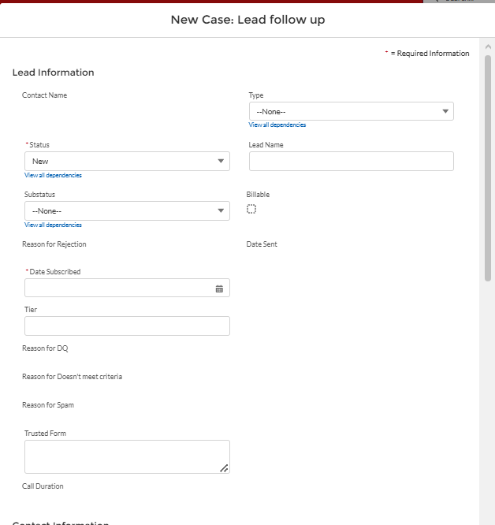

TYPE (Drop Down Options)
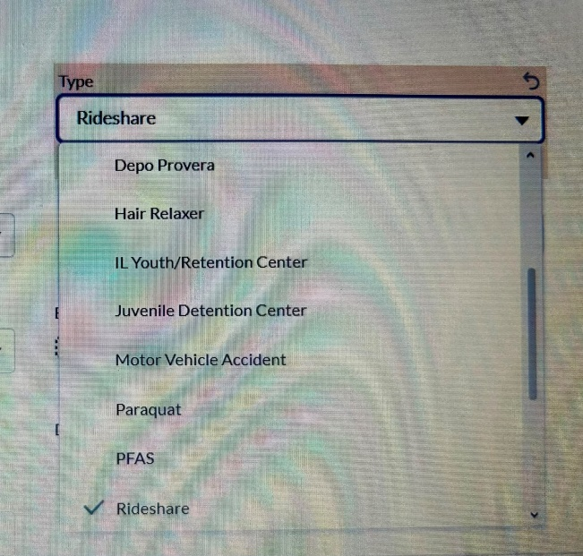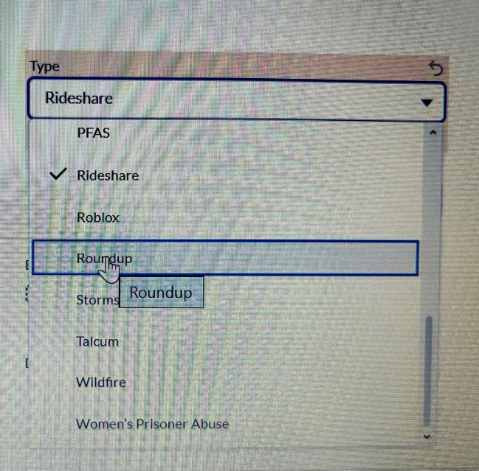
Status (Drop Down Option)
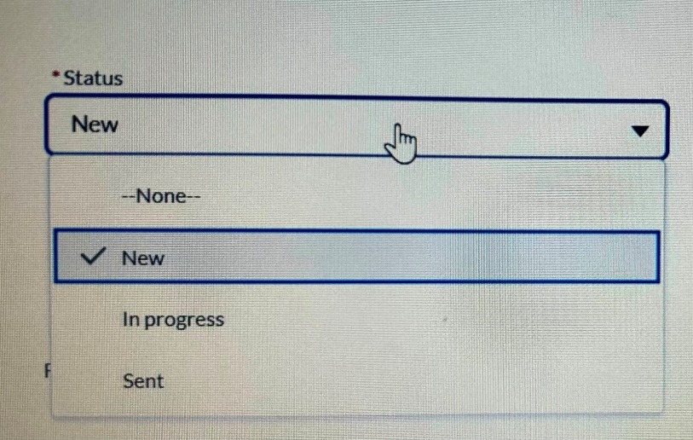
Substatus (Drown Down Option)
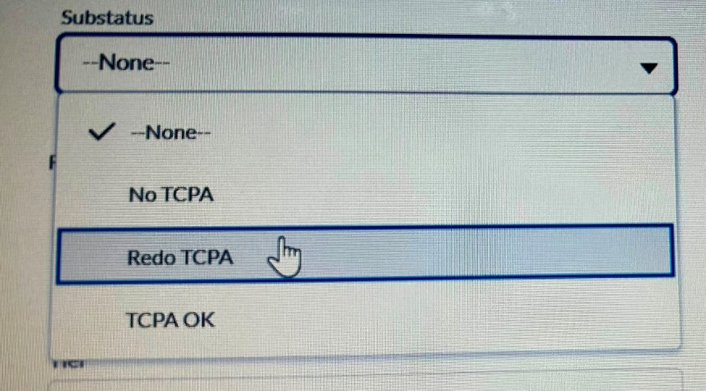

Date Subscribed
Format – Month/Date/Year (ex.12/31/2026) (SHOULD BE USED FOR ALL DATES)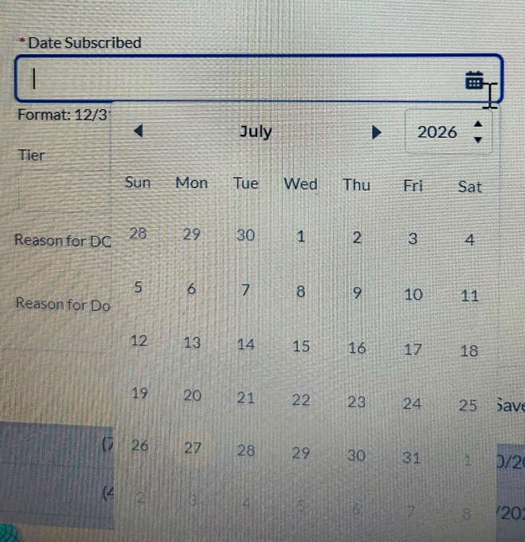

Contact Information
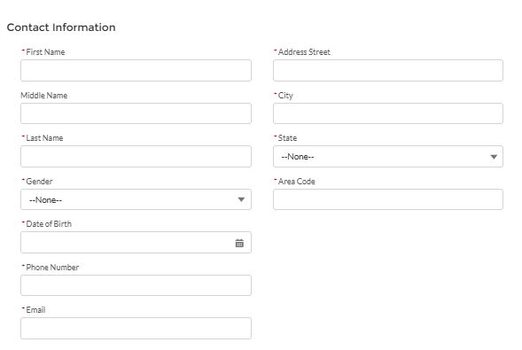
Gender (Drop Down Option)
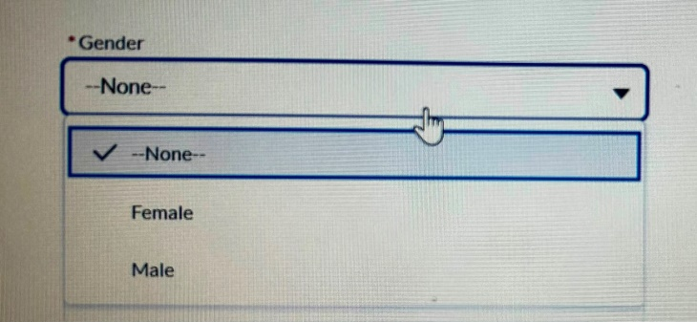

State (Drop Down Option)
(ALL US 50 STATES ABBREVATION SHOULD BE ADDED)
• AL
• AK
• AZ
• AR
• CA
• CO
• CT
• DE
• FL
• GA
• HI
• ID
• IL
• IN
• IA
• KS
• KY
• LA
• ME
• MD
• MA
• MI
• MN
• MS
• MO
• MT
• NE
• NV
• NH
• NJ
• NM
• NY
• NC
• ND
• OH
• OK
• OR
• PA
• RI
• SC
• SD
• TN
• TX
• UT
• VT
• VA
• WA
• WV
• WI
• WY
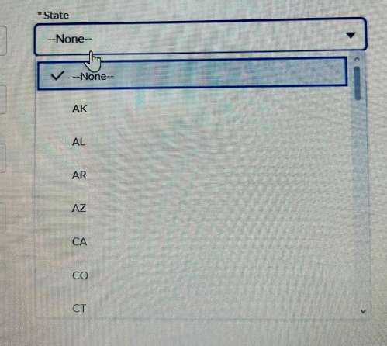

POA
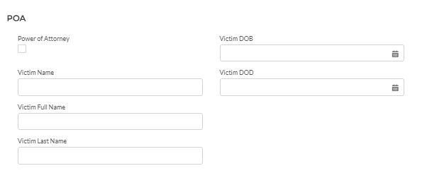
DIAGNOSIS INFORMATION
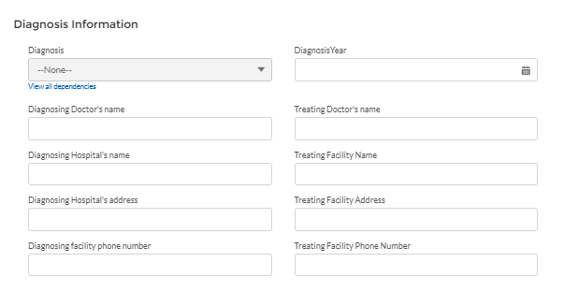
Q) Diagnosis (Drop Down Answer Options)
Sexual Dysfunction
PTSD (Post-Traumatic Stress Disorder)
Anxiety
Depression
Other
Pls add this Question before Diagnosis Ques/Option
Q)Which Incident occurred:-
Oral Vaginal/anal – Rape
Vaginal/anal – Penetration

OTHER CASE INFORMATION

Other Case Information

Which facility were you housed in?
• Maclaren Hall / MacLaren Juvenile Hall
• Barry J. Nidorf Juvenile Hall
• Slymar Juvenile Hall (Barry J. Nidorf Juvenile Hall)
• Los Padrinos Juvenile Hall
• Central Juvenile Hall
• Camp David Gonzales
• Camp Jarvis
• Camp Karl Holton
• Camp Kenyon Scudder
• Camp Kilpatrick
• Camp McNair
• Camp Onizuka
• Camp Resnick
• Camp Scobee
• Camp Scott
• Camp Smith
• Challenger Camps
• Los Prietos Boys Camp
• Dorothy F. Kirby Center
• Fred C. Nelles Youth Correctional Facility
• LAC Afflerbaugh Paige Camp
• Southern Youth Correctional Reception Center & Clinic

Reason of getting detained
For Answer (pls add Blank Box)
Prisoner Id. –
For Answer (pls add Blank Box)
Approximate Intake date –
For Answer (Date Selection)
Approximate Release date -
For Answer (Date Selection)
Juvenile Booking Number/ Case Number/Probation Case Number/ Court Case Number -
For Answer (pls add Blank Box)

Housing Unit/Dorm-
For Answer (pls add Blank Box)
Room / Cell Identifier –
For Answer (pls add Blank Box)
Bed assignment -
For Answer (pls add Blank Box)
Name & Officer of Alleged staff member -
For Answer (pls add Blank Box)
First Abuse Incident Date – For Answer (Date Selection)
Last Abuse Incident Date - For Answer (Date Selection)
How many times were you Abused?
For Answer (pls add Blank Box)
Which place/Room did it occur in Detention Center?
For Answer (pls add Blank Box)
Did you reported this incident while in custody?
Family Member
Counselor
Probation Officer
Describe the whole Incident what happened?
For Answer (pls add Big Blank Box)
Emotional Changes / Symptoms Before:-
For Answer (pls add Blank Box)
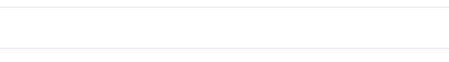
Symptoms Started Date :- For Answer (Date Selection)

How did they Confirmed your Diagnosis / Test before Diagnosis :-

Date of Test :- For Answer (Date Selection)

Treatment :-

Treatment Date :- For Answer (Date Selection)

Did you have any legal representation with any law firm regarding this claim?
Yes
No

Conviction Felony/Crime?
YES
NO

Do you have Medical Records?
Yes
No
Do you have juvenile records?
Yes
No

